PHP Candidates Test 曹利文

* Laravel 8
* MySQL 8
* Redis

1. Create an API endpoint that can accept 2 parameters “id1” and “id2” by POST method
2. Create a table in MySQL database to store the id1, id2 and a userID
3. When the system receives the request :
   1. Check from the database to see if id1 and id2 exist in the table (in the same row)
   2. If yes, get the userID and output to response in JSON format
   3. If not, generate a userID in UUIDv4 format, insert into table, and then output the userID to response in JSON format
4. Please draw a sequence diagram of your system

Bonus point :

1. Create a DockerFile or docker-compose for deploying the service in docker container

Please submit the project through git repo.

答：

1）因为我手上没有laravel项目，刚好我这边是tp框架所以我就用tp框架写了

业务部分：

**<?php  
declare** (strict_types = 1);  
**namespace** app\controller\api;  
  
**use** think\Request;  
  
**use** app\BaseController;  
**use** think\facade\Db;  
  
**class** CandidatesTest **extends** BaseController{  
  
 **public function** getUse(Request $request){  
 $id1=trim($request->param('id1'));  
 $id2=trim($request->param('id2'));  
 $data['id1']=$id1;  
 $data['id2']=$id2;  
 **return** json_encode($data);  
 }  
}

路由器：

Route::*post*('api/getuses', 'api.CandidatesTest/getUse');//获取用户

结果：

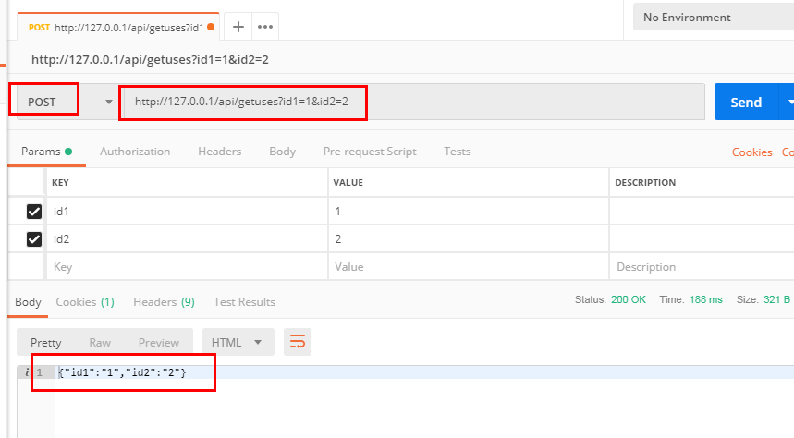

# 创建数据库的话我一般是用phpMyAdmin

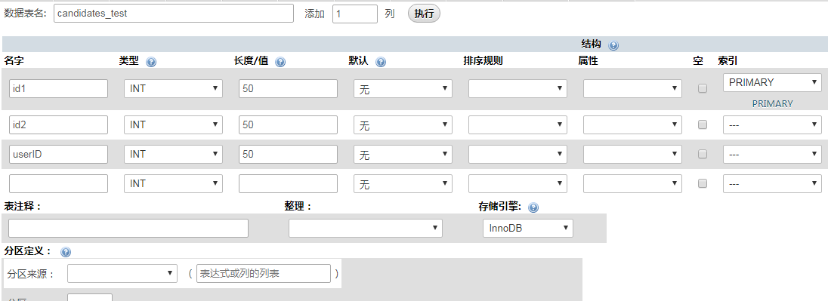

3）

业务代码：

**public function** checkUse(Request $request){  
 $id1=trim($request->param('id1'));  
 $id2=trim($request->param('id2'));  
 $rep=Db::*table*('candidates_test')->where('id1',$id1)->where('id2',$id2)->find();  
 **if** ($rep){  
 $data['code']=0;  
 $data['msg']="查询成功";  
 $data['data']=$rep;  
 }**else** {  
 $chars = md5(uniqid((string)mt_rand(), **true**));  
 $uuid = substr ( $chars, 0, 8 ) . '-'  
 . substr ( $chars, 8, 4 ) . '-'  
 . substr ( $chars, 12, 4 ) . '-'  
 . substr ( $chars, 16, 4 ) . '-'  
 . substr ( $chars, 20, 12 );  
  
 $saveData['userID']=$uuid;  
 $rep=Db::*table*("candidates_test")->save($saveData);  
**if** ($rep){  
 $data['code']=0;  
 $data['msg']="添加成功";  
 $data['data']=$uuid;  
}**else**{  
 $data['code']=1;  
 $data['msg']="添加失败";  
 $data['data']="";   
}  
  
  
 }  
  
 **return** json_encode($data);  
 }

路由器：

Route::*post*('api/checkUse', 'api.CandidatesTest/checkUse');//检查用户

结果：

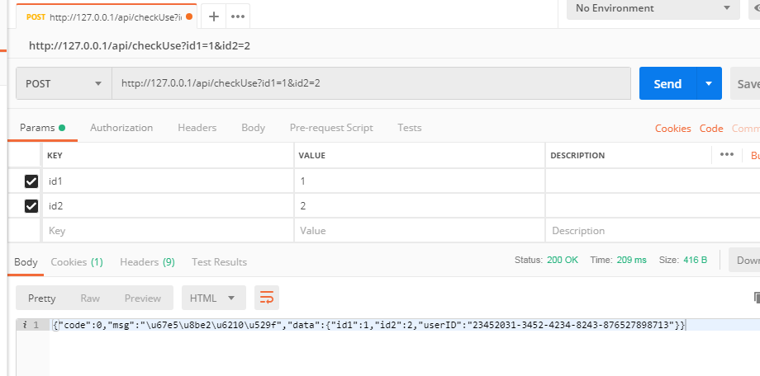

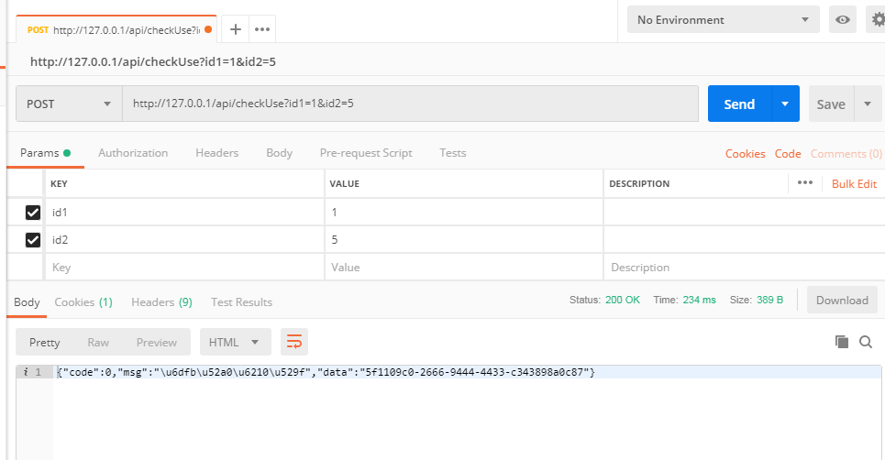

1. 系统的序列图

